**Embedded Software and Hardware Design Aspects for Smartwatch Systems**

**Introduction:-**

* The smartwatch market has witnessed rapid growth in recent years, driven by advancements in embedded software and hardware technologies. These devices have evolved from simple timekeeping tools to multifunctional wearables capable of tracking health metrics, running native apps, and facilitating seamless communication. This review explores the key aspects of embedded software and hardware design necessary to create small, reliable, and efficient smartwatch systems.

**Embedded Software:-**

* 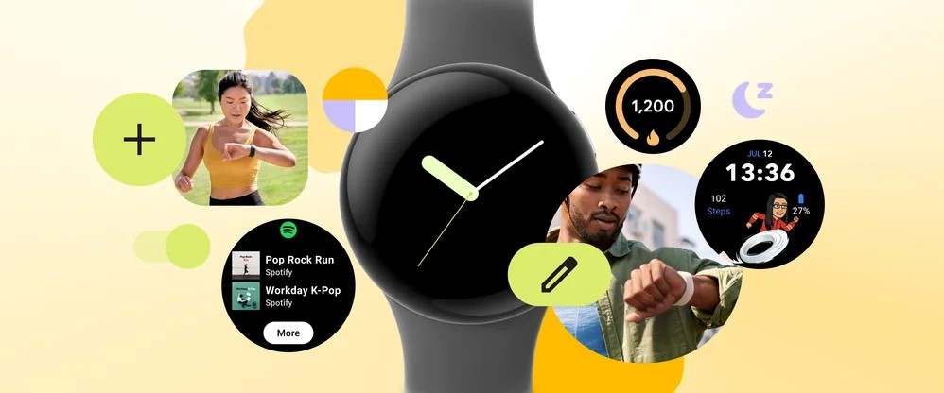**Operating System:** The operating system (OS) provides the core functionality of the smartwatch. It manages hardware resources, runs applications, and provides an interface for user interaction. For smartwatches, popular OS options include Wear OS by Google, watchOS by Apple, and Tizen by Samsung.
* **Application Development:** Smartwatches support native app development, allowing developers to create customized applications that extend the functionality of the device. These apps can access hardware features, such as sensors and communication modules, and can interact with the user through the touchscreen or voice commands.



* **User Interface:** The user interface (UI) is responsible for presenting information to the user and receiving input. It should be designed to be intuitive, easy to use, and visually appealing. Smartwatches typically use a combination of touch gestures, buttons, and voice commands for user interaction.
* **Connectivity:** Smartwatches can connect to other devices via Bluetooth, Wi-Fi, or cellular networks. This allows them to receive notifications, send and receive messages, and access online services.
* **Power Management:** Power consumption is a critical concern for smartwatches, as they are typically powered by small batteries. The software should be designed to minimize power consumption by optimizing resource utilization and implementing power-saving modes.

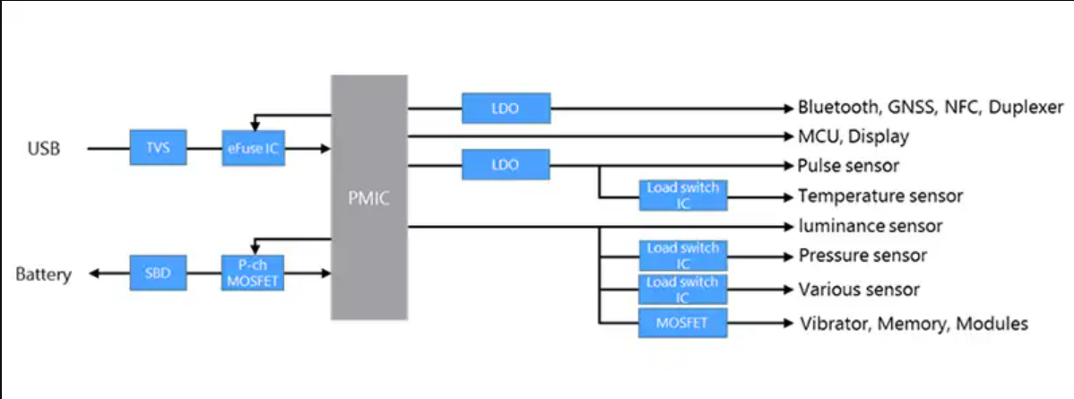

**Hardware:-**

* **Processor:**
* The processor acts as the central processing unit (CPU) of the smartwatch, analogous to the brain in a human body. It is responsible for executing instructions, performing calculations, and managing various tasks.
* In the context of smartwatches, power efficiency is crucial due to the limited space and battery capacity. Thus, low-power processors are preferred, which can perform tasks efficiently without draining the battery quickly.
* Performance-per-watt ratio is a key metric for evaluating processors in smartwatches. It measures how much computational power a processor can deliver per unit of power consumed, highlighting the balance between performance and energy efficiency.
* **Memory:**
* Smartwatches require both RAM (Random Access Memory) and storage memory.
* RAM is used for storing temporary data while the smartwatch is operational. It allows for quick access to data required for running applications and performing tasks.
* Storage memory is used for storing applications, user data, settings, and other permanent content. This memory is essential for the overall functionality and personalization of the smartwatch.
* **Sensors:**
* Smartwatches are equipped with various sensors to collect data on user activity, movement, and environmental conditions.
* Accelerometers detect changes in speed and direction, enabling features like step counting and gesture recognition.
* Gyroscopes measure orientation and rotation, aiding in tracking movements and gestures.
* Heart rate monitors track the user's heart rate, providing valuable health and fitness information.
* GPS receivers enable location tracking and navigation services, allowing users to track their outdoor activities and receive location-based notifications.

**Display:**

* The display serves as the primary interface for user interaction with the smartwatch.
* It should be high-resolution to ensure clear and sharp visuals, enhancing the user experience.
* Brightness is essential for readability, especially in outdoor environments.
* Energy efficiency is crucial to minimize battery consumption, particularly in devices with limited battery capacity.
* Common display technologies used in smartwatches include OLED (Organic Light-Emitting Diode) and LCD (Liquid Crystal Display).

**Battery:**

* The battery provides the necessary power to operate the smartwatch.
* Longevity is essential to ensure extended usage without frequent recharging.
* The battery should be capable of supporting the device's features and usage patterns, including continuous use of sensors, display, and wireless connectivity.
* Fast-charging capabilities may also be desirable for quick recharging when needed.

**Form Factor:**

* The form factor refers to the physical design and dimensions of the smartwatch.
* It plays a crucial role in both aesthetics and functionality.
* The smartwatch should be small and lightweight enough to be comfortably worn on the wrist throughout the day.
* Despite the compact size, it should still provide sufficient space to accommodate essential hardware components, including the processor, memory, sensors, battery, and display.
* The design should also consider factors such as durability, water resistance, and ergonomic considerations to ensure user comfort and satisfaction.

**Recent Advancements in Smartwatch Design:-**

* **User Experience:**
* Improved Displays: Smartwatches now feature high-resolution, always-on displays that ensure readability in various lighting conditions, enhancing user experience by providing clear visuals at all times.
* Enhanced Touchscreens: Touchscreens have undergone improvements in responsiveness and accuracy, facilitating smoother navigation through the user interface and improving overall usability.
* Voice Control: Integration of voice control allows users to interact with smartwatches through voice commands, offering hands-free operation for tasks like setting alarms, sending messages, and controlling music playback, thereby enhancing convenience and accessibility.
* **Health Monitoring:**
* Advanced Sensors: Smartwatches incorporate an array of advanced sensors, including heart rate monitors, blood oxygen sensors, and ECG sensors, enabling detailed health monitoring and providing users with comprehensive insights into their well-being.
* Health Tracking Features: These devices offer extensive health tracking capabilities, including monitoring steps taken, calories burned, sleep quality, and stress levels, empowering users to monitor and manage their health proactively.
* Integration with Health Apps: Smartwatches seamlessly integrate with health apps on smartphones, facilitating the tracking and analysis of health data over time, and enabling users to share vital information with healthcare professionals for better management of their health.
* **Battery Life:**
* Energy-Efficient Processors: Smartwatches utilize energy-efficient processors that optimize power consumption, thereby extending battery life and ensuring prolonged usage between charges.
* Adaptive Display Brightness: Smartwatches employ adaptive display brightness technology, automatically adjusting screen brightness based on ambient light conditions, which not only enhances visibility but also conserves battery power.
* Power-Saving Modes: Incorporation of power-saving modes allows users to conserve battery life by disabling non-essential features or reducing performance when the device is not in active use, ensuring prolonged usage in situations where charging may not be immediately available.
* **Hardware Design:**
* Smaller and Lighter: Continuous advancements in design have led to smartwatches becoming increasingly compact and lightweight, enhancing comfort for wearers and making them more conducive for everyday use.
* Improved Durability: Modern smartwatches are built to withstand the rigors of daily use, featuring enhanced durability against water, dust, and shock, thereby ensuring longevity and reliability in various environmental conditions.
* Customizable Designs: Smartwatches offer extensive customization options, including interchangeable watch bands and customizable watch faces, allowing users to personalize their devices according to their preferences and style.
* **Future Innovations:**
* Flexible Displays: Future smartwatches may incorporate flexible display technology, enabling unique form factors and innovative user interaction possibilities.
* Non-Invasive Health Monitoring: Integration of non-invasive sensors for monitoring health metrics such as blood pressure and glucose levels could revolutionize health monitoring capabilities, providing users with valuable insights into their overall well-being.
* Augmented Reality Integration: Integration with augmented reality (AR) technology could enable smartwatches to deliver enhanced information and experiences, opening up new avenues for interaction and utility.
* **Design Aspects:**
* Small Size and Low Weight: Smartwatches should maintain a compact and lightweight design to ensure comfortable wearability throughout the day.
* Reliability: Smartwatches should be robust and durable, capable of withstanding daily wear and tear as well as exposure to environmental elements such as water, dust, and shock.
* Efficiency: Energy efficiency is crucial to maximize battery life, ensuring prolonged usage without frequent recharging.
* User-Friendliness: Smartwatches should feature an intuitive user interface that is easy to navigate, enhancing user experience and accessibility for a wide range of users.
* Customization: Offering customization options such as interchangeable watch bands, customizable watch faces, and personalized settings allows users to tailor their smartwatch experience to suit their individual preferences and needs.
* **Ongoing Research On Smart Watches :-**

1. **A Smartwatch Step Counter for Slow and Intermittent Ambulation**

* The research focuses on the development and validation of a step counter designed for situations where ambulation may be slow and intermittent, particularly targeting the walking habits of elderly individuals.
* 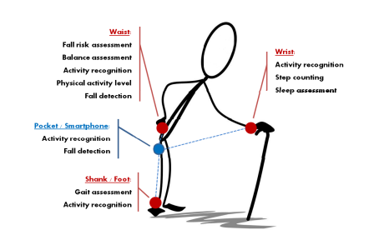The study emphasizes the significance of automatic step detection in monitoring systems, highlighting the importance of accurately quantifying mobility, physical activity levels, and fall risk in the elderly population. The researchers aimed to address the limitations of existing commercial devices by developing a custom wearable app named ADAM, which processed accelerometer data from a Gear 2 smartwatch.

Figure 1: System Architecture

* To evaluate the performance of the step counter, the researchers conducted experiments involving two groups of subjects. The training dataset included accelerometer data from eight subjects who performed the Walk-turn-walk activity, while the testing dataset involved eight different subjects performing various activities listed in Table 1 of the paper. The subjects were instructed to walk at different speeds, including slower and much slower than normal, to simulate conditions typical of elderly individuals.
* 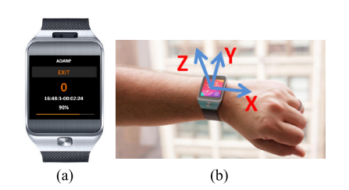The experimental protocol ensured minimal biases by instructing subjects to move as naturally as possible without providing feedback on the step count output. The initialization process involved a 2-second interval where subjects stood still in a neutral posture to determine the smartwatch's wrist placement. The researchers observed the participants during activities to manually count the steps walked, serving as a reference for evaluating the algorithm's performance.

**Figure 2: Experimental Setup**

* The training procedure for the ADAM app involved identifying and tuning parameters such as λM, Kd, Amin, and Stmin to optimize algorithm performance. The study highlighted the importance of the time delay parameter Kd in the proposed WPD method, emphasizing its impact on detection sensitivity and specificity. Through offline tuning and grid search, the researchers achieved 100% specificity with the selected parameter settings.
* The results indicated that the ADAM app exhibited similar accuracy levels to the native step counter in the smartwatch and a waist-worn step counter during normal walking conditions. However, it outperformed these devices in scenarios involving slow and intermittent ambulation. The novel approach to dynamic thresholding implemented in the WPD algorithm showed promise for robust step counting in challenging walking conditions.

1. **Design and Measurement of a Compact Millimeter Wave Highly Flexible MIMO Antenna Loaded With Metamaterial Reflective Surface for Wearable Applications :-**

* The research paper focuses on the design and measurement of a compact millimeter wave highly flexible MIMO antenna loaded with a metamaterial reflective surface for wearable applications. The study aims to enhance the performance of wearable antennas by incorporating metamaterials, which have unique electromagnetic properties not found in natural materials.
* The proposed antenna design features a compact size, making it suitable for integration into various wearable devices such as wristwatches, wristbands, and clothing for 5G applications. By utilizing metamaterials in the antenna structure, the researchers were able to achieve improved radiation characteristics and reduced radio frequency energy penetration on the human body. This resulted in a specific absorption rate (SAR) of 0.86 and 0.8 W/kg for 1g of tissue at a distance of 10 mm, indicating a safe level of exposure.
* The study includes detailed measurements and analysis of the antenna's performance, both in free space and on-body scenarios. The results of the on-body measurements and diversity parameters were found to be satisfactory, demonstrating the antenna's effectiveness in real-world wearable applications.
* Furthermore, the research paper discusses the growing importance of wearable technology in various industries, with a focus on health monitoring and seamless connectivity. The demand for high data rate connectivity in wearable devices, especially in wristwear devices, underscores the need for advanced antenna designs that can operate efficiently in the millimeter wave spectrum.
* Overall, the research contributes to the advancement of wearable technology by introducing a novel antenna design that leverages metamaterials to enhance performance and ensure user safety. The findings of the study have implications for the development of future wearable devices, particularly in the context of 5G applications where high-speed data transmission and reliable connectivity are essential.
* In conclusion, the research paper presents a significant step forward in the field of wearable antennas, showcasing the potential of metamaterials to improve antenna performance and address the unique challenges of integrating antennas into wearable devices.

**Conclusion:-**

Creating small, reliable, and efficient smartwatch systems requires careful consideration of both embedded software and hardware design aspects. By optimizing the software and hardware components, manufacturers can develop smartwatches that meet the needs of users and provide a seamless and enjoyable user experience.